JEREMIAH ALBERT ROBEY LZZD-RSL AND MARTHA JANE DOWDLE ROBEY KWJ1-GBD a
Midway Fort Family, written by Jason Moulton
Their cabin was located in the Southwest corner of the Midway fort sandwiched between the cabins of Sidney Epperson and Simon Higgenbotham. It is noted that their cabin was just north of his father's cabin (Jeremiah Robey Jr.”
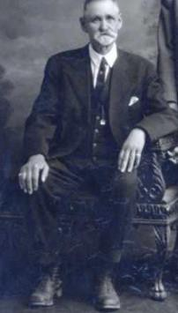

Jeremiah Albert Robey was born on 12 March 1846, in Nauvoo, Hancock, Illinois, United States, his father, Jeremiah Robey Jr, was 36 and his mother, Ruth Tucker, was 29. He married Martha Jane Dowdle on 22 November 1865, in Salt Lake City, Salt Lake, Utah, United States. They were the parents of at least 2 sons and 6 daughters. He lived in Clinton, Davis, Utah, United States in 1900 and Arlington, Wasco, Oregon, United States in 1910. He died on 20 November 1921, in Ogden, Weber, Utah, United States, at the age of 75, and was buried in Salt Lake City Cemetery, Salt Lake City, Salt Lake, Utah, United States.

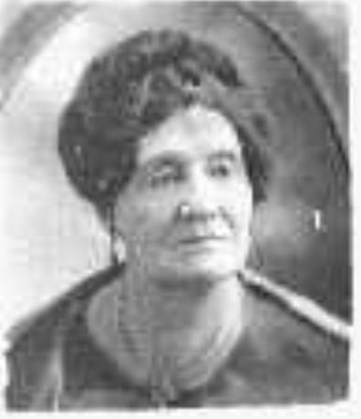
Martha Jane Dowdle was born on 22 August 1847, in Salt Lake, Utah, United States, her father, Absalom Porter Dowdle, was 28 and her mother, Sarah Ann Holladay, was 19. She married Jeremiah Albert Robey on 22 November 1865, in Salt Lake City, Salt Lake, Utah, United States. They were the parents of at least 2 sons and 6 daughters. She lived in Arlington, Wasco, Oregon, United States in 1910 and Ogden, Weber, Utah, United States in 1920. She died on 7 November 1929, in Salt Lake, Utah, United States, at the age of 82, and was buried in Salt Lake City, Salt Lake, Utah, United States.
It is noted that the Absalom Porter Dowdle Family are believed to have been residents in the Heber Fort. It is very likely that Martha Jane Dowdle met her husband while living in the Heber area.
JEREMIAH ALBERT AND MARTHA JANE DOWDLE ROBEY” Taken from, How Beautiful Upon the Mountains page 670 -671”
“Jeremiah Albert Robey, son of Jeremiah Robey and Ruth Tucker Robey. Born March 12, 1845, in Hancock County, Illinois. Married Martha Jane Dowdle in 1860. (note family search indicates the marriage was 22 November 1865) Died November 20, 1921. Buried in Salt Lake City, Utah.
Martha Jane Robey, daughter of Porter Dowdle and Sarah Ann Halladay Dowdle. Died November 7, 1929, buried in Salt Lake City, Utah.;

Jeremiah came to Utah with his parents in the David Wood Company in 1852. His early life was spent in Provo, where he had access to his father’s carpenter shop. He became an expert carpenter. He was a natural musician, and played the violin, helping to furnish music for many of the dances and entertainments.
He moved to Midways with his parents in 1859. He resided here for several years, working his trade as a carpenter.
Mr. Robey was a veteran of the Black Hawk War and took part in all of the early projects of pioneer life. He was of a quiet, unassuming disposition: he made many friends and kept them. He was familiarly known as “Jed” and wherever he went he was welcome. His wife was a real helpmate to him and shared in all of his joys and sorrows. She was very cheerful and jovial in her disposition and was good company.”
Their eight children are as follows:
Leonore Robey was born on 14 September 1866, in Midway, Wasatch, Utah, United States, her father, Jeremiah Albert Robey, was 20 and her mother, Martha Jane Dowdle, was 19.
She died as an infant.

Mary Jane Robey was born on 12 August 1868, in Midway, Wasatch, Utah, United States, her father, Jeremiah Albert Robey, was 22 and her mother, Martha Jane Dowdle, was 20. She married Joseph John Tietjen on 5 April 1889, in Vernal, Uintah, Utah, United States.
They were the parents of at least 1 son and 1 daughter. She lived in Santaquin, Utah, Utah, United States for about 30 years. She died on 19 May 1934, in Kelso, Cowlitz, Washington, United States, at the age of 65, and was buried in Santaquin City Cemetery, Santaquin, Utah, Utah, United States.

Electa Ruth Robey was born on 13 May 1870, in Midway, Wasatch, Utah, United States, her father, Jeremiah Albert Robey, was 24 and her mother, Martha Jane Dowdle, was 22. She married Harold Perry Heninger on 3 September 1891, in Colton, Utah, Utah, United States. They were the parents of at least 3 sons and 3 daughters. She lived in Ogden, Weber, Utah, United States in 1920 and Los Angeles, Los Angeles, California, United States in 1930. She died on 4 May 1958, in Salt Lake City, Salt Lake, Utah, United States, at the age of 87, and was buried in Wasatch Lawn Memorial Park, Millcreek, Salt Lake, Utah, United States.

Jeremiah Albert Robey Jr was born on 22 October 1873, in Midway, Wasatch, Utah, United States, his father, Jeremiah Albert Robey, was 27 and his mother, Martha Jane Dowdle, was 26. He married Emma Elizabeth Larsen on 19 September 1900, in Provo, Utah, Utah, United States. They were the parents of at least 3 sons and 1 daughter. He lived in Cleveland, Emery, Utah, United States in 1910 and Price, Carbon, Utah, United States in

1930. He died on 17 December 1953, in Los Angeles, Los Angeles, California, United States, at the age of 80, and was buried in Inglewood Park Cemetery, Inglewood, Los Angeles, California, United States.
Matilda Evelyn Robey was born on 8 July 1878, in Midway, Wasatch, Utah, United States, her father, Jeremiah Albert Robey, was 32 and her mother, Martha Jane Dowdle, was 30. She married James Justenious Dahl on 11 January 1905, in Salt Lake City, Salt Lake, Utah, United States. They were the parents of at least 2 sons and 3 daughters. She lived in Clinton, Utah, Utah, United States in 1900. She died on 8 July 1963, in Salt Lake City, Salt Lake, Utah, United States, at the age of 85, and was buried in Wasatch Lawn Memorial Park, Millcreek, Salt Lake, Utah, United States.
Sidney Theophilus Robey was born on 26 June 1881, in Midway, Wasatch, Utah, United States, his father, Jeremiah Albert Robey, was 35 and his mother, Martha Jane Dowdle, was
33. He married Ethel Winnifred Whitmore on 14 September 1907, in Provo, Utah, Utah, United States. He lived in Salt Lake City, Salt Lake, Utah, United States in 1950. He died on 5 June 1950, in Salt Lake, Utah, United States, at the age of 68, and was buried in Wasatch Lawn Memorial Park, Millcreek, Salt Lake, Utah, United States.

Henerietta Bessie Robey was born on 8 October 1882, in Midway, Wasatch, Utah, United States, her father, Jeremiah Albert Robey, was 36 and her mother, Martha Jane Dowdle, was
35. She married Adam Richard Ludwig on 23 December 1905, in Salt Lake City, Salt Lake, Utah, United States. They were the parents of at least 2 sons. She lived in Arlington, Wasco, Oregon, United States in 1910 and Ogden, Weber, Utah, United States in 1920. She died on 1 November 1926, in Portland, Multnomah, Oregon, United States, at the age of 44, and was buried in Salt Lake City, Salt Lake, Utah, United States.

Martha Sophia Robey was born on 4 July 1884, in Vernal, Uintah, Utah, United States, her father, Jeremiah Albert Robey, was 38 and her mother, Martha Jane Dowdle, was 36. She married John Gibbs Smith on 27 March 1903, in Provo, Utah, Utah, United States. They were the parents of at least 1 son. She lived in Clinton, Utah, Utah, United States in 1900 and San Francisco, San Francisco, California, United States in 1920. She died on 26 August 1959, in Salt Lake City, Salt Lake, Utah, United States, at the age of 75, and was buried in Wasatch Lawn Memorial Park, Millcreek, Salt Lake, Utah, United States.
A search of the Bureau of Land Management General Land Office Records indicates that Jeremiah A. Robey was granted 160 acres via the Homestead on 16 June 1896. This property in located near Highway 6 near Tabbyune Creek in Utah County. His father also had a homestead very near there.

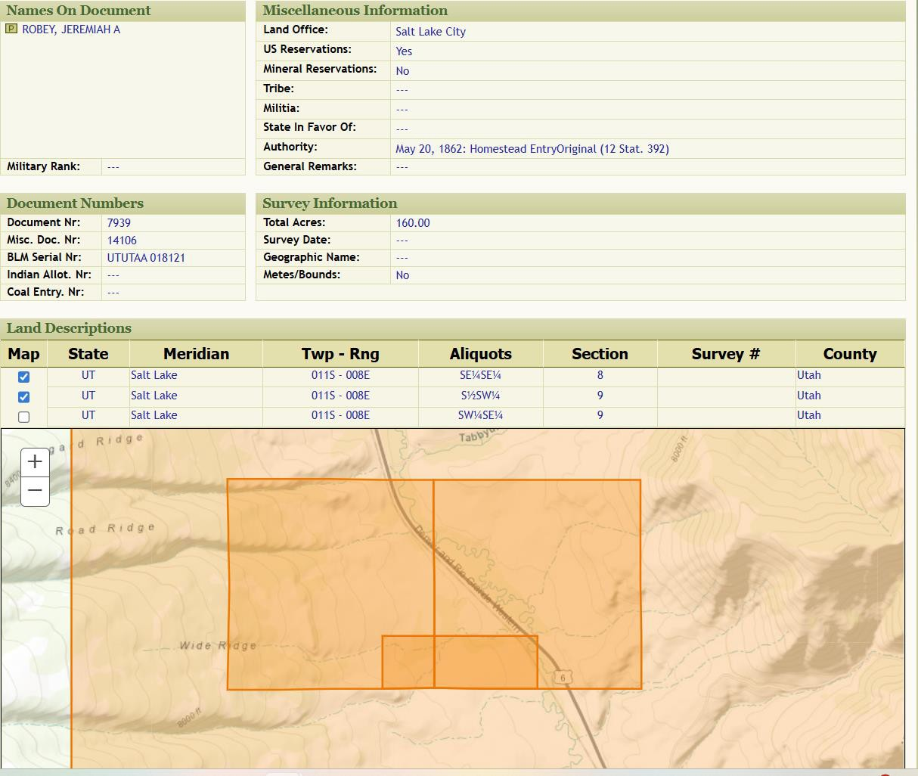
Heber Valley Heritage Foundation

